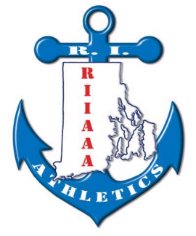**Rhode Island Interscholastic**

**Athletic Administrators Association**

2019-2020

Dear Athletic Director:

__________________________________________________________________________________________________________________________________________________________________________________________________________________________________________________________________________________________________________________________________________________________________________________________________________________________________________________________________________________________________________________________________________________________________________________________________________________________________________________________________________________________________________________________________________________________________________________________________________________________________________________________________________________________________________________________________________________________________________________________________________________

The RIIAAA annual awards banquet is scheduled for Monday,

March 30, 2019 at the Crowne Plaza. As has been our past practice

to have an awards program book for this dinner. The RIIAAA appreciates all of our members and hopes that they will support this event by purchasing an ad for this book.

The ad prices will be as follows:

(1/8 Page $40, 1/4 Page $70, 1/2 Page $90 or Full Page $130)

Please complete the bottom portion of this note and return it with your ad copy no later than March 1st. Thank-you very much for your support!!

___ ___Enclosed is a new ad _____Use last year’s ad

School_____________________________________ ________________________________

Our ad will be: (Please Check one)

1/8 Page ________$40

1/4 Page ________ $70

1/2 Page ________ $90

Full Page ________$130

Please return this form to and remittance payable to RIIAAA:

c/oBeth Penkala, RIIAAA

51 Almy Avenue

Warren, RI 02885-3701

A check payable to RIIAAA for $ *_____*is enclosed.

AD Signature ________________________________

(**Deadline for returns is March 1st)**