Rhode Island Interscholastic Athletic Administrators Association

NEWSLETTER
September 2013

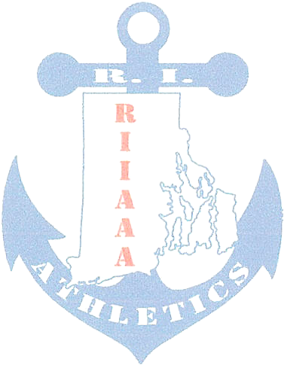
The RIIAAA Executive Board would like to thank its members for all its dedication to athletics in the state of Rhode Island. Through your effort, student-athletes are able to attain higher goals and enrich their lives through sport.

We would also like to make you aware of our efforts to find better avenues to communicate with you. Our duty is to represent you and your needs to the best of our ability. Should you have an issue or idea that you feel our membership needs to be aware of please contact one of us? You are also encouraged to attend any Executive Board meeting to voice a concern or just see what we do once a month at the RIIL at RIC.

The following important information, which has come out of discussions from our recent meeting, is to help keep you aware of current issues or concerns in Rhode Island athletics.

- Regretfully, the RIIAAA Executive Board accepted the resignation of Paul Amaral, East Providence from the board. On behalf of the RIIAAA membership, the Executive Board wishes Paul continued success in education as he continues to serve his community as a classroom teacher.

- Athletic Directors serving as either Director or Co-Director of a sport committee are reminded to send meeting report(s) to Bob Palazzo Robert.Palazzo@ppsd.org as soon as possible. In order for Jeff Maidment and Mike Traficante to best serve you at Principals’ Committee on Athletics meetings, Bob would need to pass on sport committee resolutions in advance of the PCOA meetings.
  - Competition Cheer sub-committee will meet Monday September 30, 2013 at RIIL 5pm and again on October 16, 2013 at RIIL 5pm.

- All but 20 member schools have returned RIIAAA membership renewal forms for 2013-2014.

- Sport Committee Reports:
  - Competition Cheer reported the addition of two judge coordinators. One to serve as lead judge trainer and the other the serve as lead official scheduler. Both will oversee the officials and hope to work cohesively with the coaches.
  - Girls’ Basketball reported that Marty Crowley has stepped down as the President of the Girls’ Basketball Coaches’ Association. Also, it was asked that discussion be brought back to the committee to look at the playoff structure.
  - Boys’ Basketball reported that the start dates for playoffs will be the end of the February break. That quarter-final games are played at the site of the higher seed with semi-final games being played at a neutral site.
  - Baseball is in need of a principal to serve on the sport committee.
  - Wrestling reported that the New England Tournament is schedule for the March 8/9, 2014 weekend at the Providence Career Technical Academy (PCTA).
  - Indoor Track reported that communication continues with the small college track programs to make use of the PCTA for their Championships. The RIIL State Indoor Track Championships is currently set for Saturday February 15, 2014 unless the CollegeTournament uses that date. If so, the RIIL States will be Sunday, February 16, 2014
  - Boys’ Lacrosse reported that the NFHS is enlarging the box 5yds in each direction. Also, no horn is needed for the transition in and out of the box on substitutions.
  - Girls’ Lacrosse reported that the alignment is delayed due to Wheeler School requesting new entry to the RIIL. PCOA does not meet until November to vote on the request.
  - Gymnastics reported the schedule is out to RIIL member schools.
  - Boys’ Soccer: Al DiGregorio reported that he was removed from the sport committee.
  - Girls’ Soccer reported that league games would end earlier than varsity so as to support the time needed to complete the JV Girls’ Soccer Championships.
  - Hockey reported that John Abbate, Burrillville, will fill a vacancy as Athletic Director on the sport committee.
  - Sports’ Medicine reported on Heat Acclimatization and coach compliance.
  - Volleyball reported issues with the training of new officials as a shadow to the assigned officials at varsity matches.
  - By-Laws committee is scheduled to meet soon. Mike Traficante, Ted Quigley and Elaine Botelho are in need of two non-board Athletic Directors to complete the committee. If interested contact M.Traficante@theproutschool.org
  - Co-Op committee chaired by Colleen Gribbin, Bay View includes George Nasuti, Woonsocket, Chris Cobain, East Greenwich, Ken Rix, Warwick Vets and Jon Donahue, Wheeler School who have agreed to serve on this committee.
  - The All–In Rule committee is looking for Athletic Director membership. All-In Rule meaning, should private and parochial schools that participate in some RIIL sports and other New England Associations for other sports, be mandated to participate 100% in the RIIL or not.

- Principals’ Committee on Athletics: No report, next meeting is November 2013.
- Workshop Evaluation to the RIIL:
  - New Rule and Regulation interpretation
  - EEE/West Nile virus information
  - The New Athletic Directors workshop should be run by veteran Athletic Directors.
- Workshop Evaluation to RIIAAA
  - There is a need to update the Strategic Plan
  - Have move regional meetings
  - More Professional Development
  - Discuss Middle School Sport more.
  - Discuss JV Playoff Structure
  - Streamlining paperwork by Athletic Directors.
  - Budgeting for the future.
  - State tournament selection and seeding process.

- The RIIAAA (www.RIIAAA.org) and The RI Injury Fund (www.RIInjuryFund.org) Websites are getting a make-over. Expect to see changes shortly.

- The NIAAA Section I Summer Institute is scheduled for June 30-July 2, 2014. The committee is looking for at least 60 attendees to fill the block of rooms contracted by Section 1.

Any questions or concerns, please contact Beth Penkala at: bethpenkala5@gmail.com

