Rhode Island Interscholastic Athletic Administrators Association

NEWSLETTER
August 2013

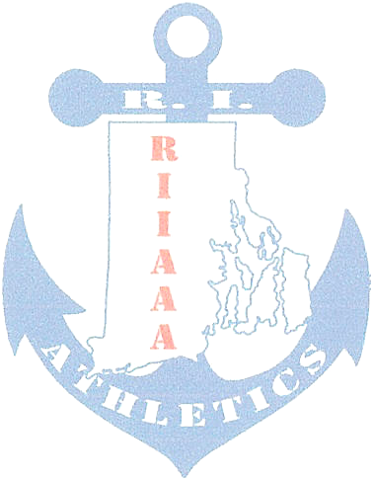
The RIIAAA Executive Board would like to thank its members for all its dedication to athletics in the state of Rhode Island. Through your effort, student-athletes are able to attain higher goals and enrich their lives through sport.

We would also like to make you aware of our efforts to find better avenues to communicate with you. Our duty is to represent you and your needs to the best of our ability. Should you have an issue or idea that you feel our membership needs to be aware of please contact one of us? You are also encouraged to attend any Executive Board meeting to voice a concern or just see what we do once a month at the RIIL at RIC.

The following important information, which has come out of discussions from our recent meeting, is to help keep you aware of current issues or concerns in Rhode Island athletics.

- Kudos to Allen Huestis, retired Ponaganset AD. The NIAAA Board of Directors has selected him to receive the Thomas E. Frederick Award of Excellence. Allen’s name was placed in nomination by the Past Presidents' Council and was wholeheartedly endorsed by the Board of Directors as someone who exemplifies the qualities of leadership as well as contributions to the field of interscholastic athletics in the tradition of Tom Frederick. Presentation of the award will take place at the NIAAA Conference in Anaheim, CA this December.

- Congratulations to Jim Cawley, Rogers HS for completing his Certified Athletic Administration (CAA) course work and exam at the Summer Institute this past July.

- The following states are commended for membership, Connecticut, Indiana, Maryland, New Hampshire, Rhode Island, Utah and Wyoming. All over 100% membership for 2012-13. The following states, regardless of commendation, currently stand at all-time records for NIAAA membership: Connecticut, Delaware, Florida, Georgia, Missouri, Nevada, Oklahoma, Rhode Island, Utah, and Wyoming. Look for the commendation banner at www.riiaaa.org as well as www.niaaa.org.

- Athletic Directors serving as either Director or Co-Director of a sport committee are reminded to send meeting report(s) to Bob Palazzo Robert.Palazzo@ppsd.org as soon as possible. In order for Jeff Maidment and Mike Traficante to best serve you at Principals’ Committee on Athletics meetings, Bob would need to pass on sport committee resolutions in advance of the PCOA meetings.
  - Competition Cheer sub-committee will meet Monday September 9, 2013.

- Seventy-five percent of member schools have returned RIIAAA membership renewal forms for 2013-2014. NIAAA is asking that all states increase their membership by one for 2013-2014. Since Rhode Island already has 100% NIAAA membership, the RIIAAA will be actively seeking Middle Schools Athletic Directors to join the RIIAAA/NIAAA ranks.

- There was discussion as to whether the RIIAAA should have its own August meeting rather than piggy-back with the RIIL Office. As both groups’ agenda is lengthy there is little time to focus on the topics presented. It is the hope of the Executive Board to have a more Round Table format at future General Meetings. Some topics of concern:

  - Heat Acclimatization
  - Family ID and its uses
  - Injury Fund Events (by Region)
  - Play On Sports
  - The Disability Webinar
  - Provisions for the Cross Gender Athlete

- Sport Committee Reports:

  - Gymnastics met to discuss scheduling.
  - Competition Cheer reported the addition of Central Falls and St. Mary Academy, Bay View.
  - Basketball reported that the start dates for playoffs will be the end of the February break, that quarter-final games are played at the site of the higher seed with semi-final games being played at a neutral site.
  - Baseball is in need of another Athletic Director to serve on the sport committee.
  - Hockey is finalizing the winter schedule. Ted Quigley, LaSalle Academy has returned to the sport committee.
  - Football has reported the officials’ transition is going well. RI officials continue to serve schools has JV and Freshmen Football officials.
  - Outdoor Track reported that the RIIL is looking to offer wheelchair races at the State meet. The Implement Rule on borrowing equipment by permission will be followed at future meets.
  - Spring Tennis discussed language change to the RIIL rules in reference to missing playoff matches.
  - Golf is discussing the future of a fall season. Ted Quigley, LaSalle Academy has returned to serve on the Golf sport committee, but we need one more AD to serve. Contact Elaine Botelho, if you are interested.
  - Wrestling reported that the winter schedule is complete.
  - Injury Fund is pleased to announce Mike Traficante, The Prout School, as the new President.
- Principals’ Committee on Athletics Report includes:

  - The Principals’ Committee on Athletics is looking to fill two vacant seats. Athletic Directors are encouraged to pass this information on to their school Principal/Assistant Principal. Nomination forms are due September 2013.

  - There is language coming soon on provisions for the Transgender Athlete.
  - Upon RIIL request, a private school must provide information on the number of students receiving 50% or greater of financial aid.
  - The realignment committee report was well received. The exception was the PCOA felt that 40% was too high when determining whether a bottom team may move down a division.
  - Colleen Gribben, Principal, Bay View will chair a subcommittee to investigate Co-Op team rules.

- The RIIAAA (www.RIIAAA.org) and The RI Injury Fund (www.RIInjuryFund.org) Websites are getting a make-over. Expect to see changes shortly.

Any questions or concerns, please contact Beth Penkala at: bethpenkala5@gmail.com

