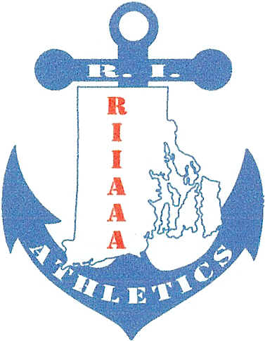
Rhode Island Interscholastic
Athletic Administrators Association
__________________________________________________________________________________________________________________________________________________________________________________________________________________________________________________________________________________________________________________________________________________________________________________________________________________________________________________________________________________________________________________________________________________________________________________________________________________________________________________________________________________________________________________________________________________________________________________________________________________________________________________________________________________________________________________________________________________________________________________________________________________

August 5, 2017

Dear Retiree,
We hope you will be interested in renewing old friendships and helping our association become a stronger voice in Rhode Island athletics. Enclosed you will find a membership form for our association 2017-2018. We know you probably do not miss the hectic schedule of an athletic director and are enjoying a more laid-back life. However, our hope is that you would still like to be apart of a group that wants to make a difference in athletics for our kids. .

Please consider becoming a member. We certainly would appreciate it. Remember, THERE IS NO FEE FOR SOCIAL EVENTS, IF YOU ARE A MEMBER. Please return your membership form as soon as possible. Remember to fill in your size. As a member you will be receiving a membership card and an association gift when you attend your first social event. Thank you in advance for taking the time to consider our request.

Sincerely,
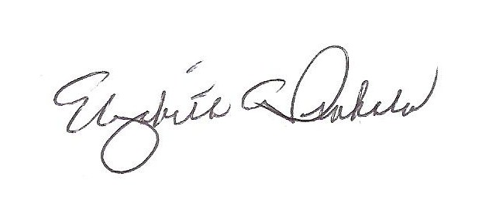
Elizabeth Penkala, CAA
Executive Director

FYI: This year our association inducted Jean Angell, retired Scituate HS; Vincent Moses, retired Classical HS; and Kenneth Hopkins, Sr., retired Cranston Schools to the RIIAAA Hall of Fame.

