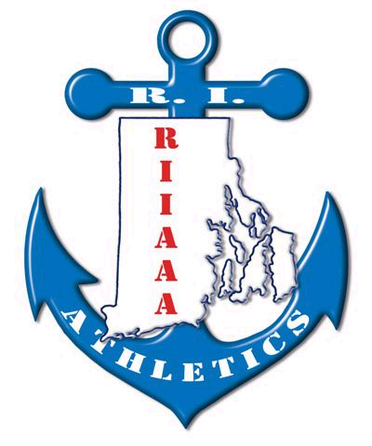
2017 RIIAAA SCHOLARSHIP
GOLF TOURNAMENT
June 23, 2017
Triggs Memorial Golf Course

Tee Signs
$75 with a foursome
$100 without golf

Yes, we would like to sponsor a Tee Sign for this year’s tournament. I have attached what we would like the sign to say, or I have written it in below.
_________________________________
_________________________________
_________________________________
_________________________________

Please make checks payable to RIIAAA and send to Chris Cobain, East Greenwich High School,
300 Avenger Drive, East Greenwich, RI. 02818.

(or send in with registration forms to Beth Penkala, RIIAAA Ex. Dir./Treasurer, 51 Almy Avenue, Warren, RI 02885)

