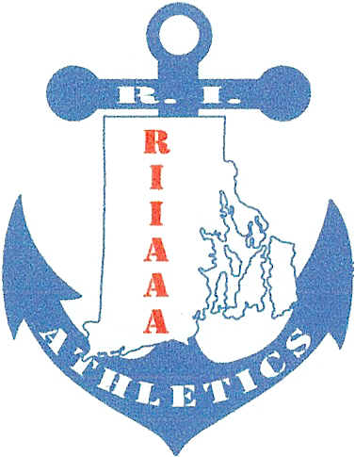
Rhode Island Interscholastic
Athletic Administrators Association
__________________________________________________________________________________________________________________________________________________________________________________________________________________________________________________________________________________________________________________________________________________________________________________________________________________________________________________________________________________________________________________________________________________________________________________________________________________________________________________________________________________________________________________________________________________________________________________________________________________________________________________________________________________________________________________________________________________________________________________________________________________
RIIAAA
Appreciation Breakfast

Thursday, December 1, 2016
9AM-11AM
Airport Radisson

Take your MVP(secretary, groundskeeper, principal,
Booster Club leader) out for breakfast to show how much
his/her efforts mean to you

$20 per person payable to RIIAAA along with number of attendees due no later than 11/28/2016 to

Beth Penkala, CAA
51 Almy Avenue
Warren, RI 02885

PAYMENTS WILL NOT BE ACCEPTED AT THE DOOR
-----------------------------------------------------------------------------------------------------------------------------------------------------------------

Name:_______________________ School:__________________

________ No. of Attendees

