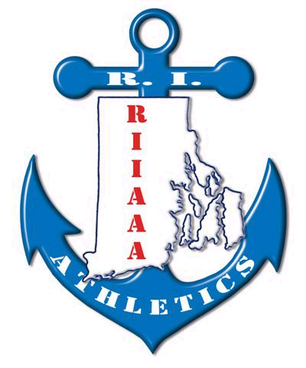
2018 RIIAAA SCHOLARSHIP
GOLF TOURNAMENT

DATE: TRIGGS MEMORIAL GOLF CLUB
PLACE: JUNE 22, 2018
Proceeds benefit the NIAAA Scholarship Fund as well as continued education for RI Interscholastic Athletic Directors’ working on their CAA certificate
(reimbursement is available for CAA required courses as funds allow).
(Looking for 60 golfers and 30 T-sponsors.)

Be a Tee Sposor: $75 ___________

PRICE: $125 per Person or $500.00 per Foursome,
Includes green fees, cart, prizes, and Dinner

4some: 1. __________________________ 2Some: 1. _______________________
2. __________________________ 2. _______________________
3. __________________________
4. __________________________ Single: _______________________

PRIZES: Closest to pin, Longest drive, and more.

lunch with awards to follow:
Lunch only: ($30.00)

DINNER ONLY: ____________________________________

RETURN FORMS AND PAYMENT TO: (Make Checks payable to RIIAAA)
Chris Cobain, Athletic Administrator
EAST GREENWICH High School
300 Avenger Drive
East Greenwich, RI 02818
(cell: 524-6933)
ccobain@egsd.net
Chris Cobain, EGHS

Ted Quigley, Athletic Administrator
La SALLE ACADEMY
612 Academy Avenue
Providence, RI 02908
(cell: 580-0593)
tquigley@lasalle-academy.org

Ted Quigley, CAA
La Salle Academy

2017 RIIAAA Scholarship Golf Tournament with 28 Golfers, 26 Tee Signs, silent auction and general raffle brought in just over $2300
Special thanks to Elmwood Sports, for donating tournament towels.
Everyone went home a winner!

