Rhode Island Interscholastic Athletic Administrators Association

NEWSLETTER
March 2011

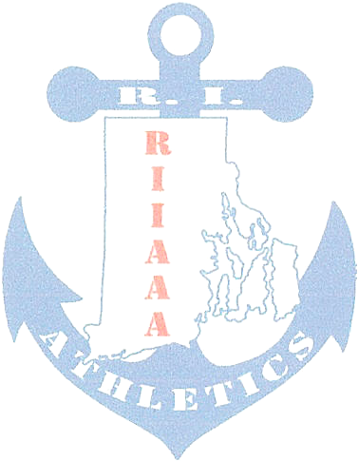
The RIIAAA Executive Board would like to thank its members for all its dedication to athletics in the state of Rhode Island. Through your effort, student-athletes are able to attain higher goals and enrich their lives through sport.

We would also like to make you aware of our efforts to find better avenues to communicate with you. Our duty is to represent you and your needs to the best of our ability. Should you have an issue or idea that you feel our membership needs to be aware of please contact one of us? You are also encouraged to attend any Executive Board meeting to voice a concern or just see what we do once a month at the RIIL at RIC.

The following important information, which has come out of discussions from our recent meeting, is to help keep you aware of current issues or concerns in Rhode Island athletics.
- The RIIAAA State Conference will be held March 22-24, Cape Cod,
MA for 2011.
- Greg Kortick (WW) and Richard Lawrence (MSC) will be presenting a workshop at the March 2011 RIIAAA State Conference, Cape Cod.
- The RIIAAA committee to review and offer revision to realignment for fall 2011 met at Moses Brown. Data for the past eight years win percentage was studied. The next consideration is Start of Season, Game Cap per sport, and Enrollment and how they play out in the realignment structure. A May 2011 presentation to the PCOA is planned.
- RIIAAA Awards Banquet is March 30, 2011 at the Crown Plaza, Warwick. 6-7pm reception with 7pm dinner and awards to follow.
- The NFHS Concussion Course has been mandated by the PCOA/RIIL to be retaken annually.
- There are 10 applicants for the NIAAA Essay Scholarship, 4 boys and 6 girls. Winners are announced at the RIIAAA Awards Banquet on March 30th.
- Terry Lynch (SK) will replace Mike Lunney on the Executive Board.
- RIIAAA is looking for a representative to seat on the Section 1 Coaches’ Education Board. To be voted on at the March 23, 2011 meeting

Any questions or concerns, please contact Beth Penkala (Mt.Hope) at penkalab@bw.k12.ri.us

