Rhode Island Interscholastic Athletic Administrators Association

NEWSLETTER
October 2014

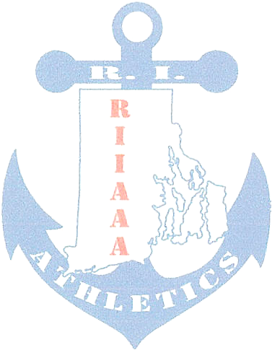
The RIIAAA Executive Board would like to thank its members for all its dedication to athletics in the state of Rhode Island. Through your effort, student-athletes are able to attain higher goals and enrich their lives through sport.

We would also like to make you aware of our efforts to find better avenues to communicate with you. Our duty is to represent you and your needs to the best of our ability. Should you have an issue or idea that you feel our membership needs to be aware of please contact one of us. You are also encouraged to attend any Executive Board meeting to voice a concern or just see what we do once a month at the RIIL at RIC.

The following important information, which has come out of discussions from our recent meeting, is to help keep you aware of current issues or concerns in Rhode Island athletics.

- AthleticDirectors serving as either Director or Co-Director of a sport committee are reminded to send meeting report(s) to Ted Quigley, La Salle Academy, tquigley@lasalle-academy.org as soon as possible in order for Jamey Vetelino to best serve you at Principals’ Committee on Athletics meetings. As the RIIAAA Vice-President, Ted would need to pass on sport committee resolutions in advance of the PCOA meetings.Athletic Directors serving as either Director or Co-Director of a sport committee are reminded to send meeting report(s) to Ted Quigley, La Salle Academy, tquigley@lasalle-academy.org as soon as possible. In order for Jamey Vetelino, Westerly, to best serve you at Principals’ Committee on Athletics meetings, As the RIIAAA Vice-President, Ted would need to pass on sport committee resolutions in advance of the PCOA meetings.
- Committee Reports:

- Baseball has set Division I at 22 teams with 16 qualifying for playoffs. Division II has 15 teams with 10 qualifying for playoffs. And the addition of Division III with 12 teams with 6 teams qualifying for playoffs.
- Boys’ Soccer committee is scheduled to meet October 25, 2014.
- Boys’ Tennis meets October 21, 2014.
- Competition Cheer indicated that the RIIL will be doing away with a regular season of Competition Cheer however; they will still sponsor a State competition. The emphasis on three cheer seasons is in the future of the Spirit Sports. ‘Game Day’ and ‘Stunt’ in addition to Competition Cheer will eventually fill the three seasons of cheer. Of the three, Stunt would be offered has a sport while the others would be considered an activity.
- Field Hockey meets the week of October 20, 2014 to set the playoff schedule.
- Outdoor Track is looking at setting the schedule based on geographic regions rather than the power ranking process. Discussion on whether Invitational(s) should follow the State Meet format versus an alternate form that has been used in the past.
- Softball has set Division I at 16 teams, Division II at 24 teams, and Division III at 9 teams. In Division II North and South crossover play and East and West crossover play. Rogers and Tiverton opted up to Division II. The Extra Inning Rule remains the same. Only the Semifinals and Finals of the State Tournament will be hosted at Rhode Island College.
- Sports Medicine is looking at a ‘return to play’ procedure for concussed athletes. Notifying school medical personnel is a must do for coaches and athletic directors.
- Swim has changed its Class and State Meet format to include a best fit for a school’s team based on performance. The Class meets will remain dual gender.
- Wrestling schedule is out to member schools.

- Mark your calendar for next year’s RIIAAA Award Banquet, Thursday, April 2, 2015. NIAAA Section I Meeting hosted by the RIIAAA, Wednesday May 13, 2015. Both events at the Crown Plaza, Warwick, RI.

- The CAA Exam will be given at Classical HS on Monday, January 5, 2015 at 8:00am. Any Athletic Director pursuing their RAA, CAA certification may seek reimbursement for the five core courses LTC 501.502, 504, 506 and 508 while funds last.

- Congratulations to Steve Nadeau, Juanita Sanchez who was selected as recipient of NIAAA conference registration and a three night’s stay at the December conference in National Harbor, Maryland.

- The next RIIAAA General Meeting is the Appreciation Breakfast, December 3, 2014 at the Airport Radisson, Warwick.

- The Winter Athletic Directors’ meeting is Wednesday, November 19, 2014 at the RIIL Office. The Spring Athletic Directors’ meeting is Wednesday, March 11, 2015 at the RIIL Office. Both at 8am.

- RIIAAA is suggesting that compatible like sports committees should be combined to one committee.

- RIIAAA Award Nominations will be sent out to the membership the first week of November 2014.
- Simultaneous participation in all sports is in the future of RIIL sports. A committee will be formed by the PCOA to discussion and study the pros and cons of such an action.

- Non-affiliate schools can play non-league games against RIIL affiliate schools (i.e. Moses Brown and Wheeler).

- The schedulers of Indoor Track are to be commended for allowing room for the PCTA to host the Little East College Invitational.

Any questions or concerns, please contact Beth Penkala at: bethpenkala5@gmail.com

