Rhode Island Interscholastic Athletic Administrators Association

NEWSLETTER
September 2014

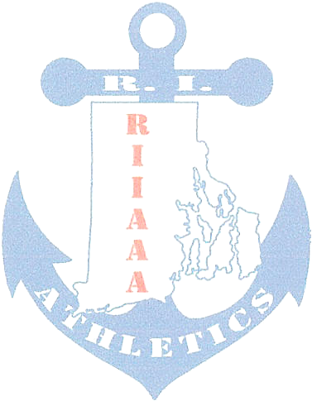
The RIIAAA Executive Board would like to thank its members for all its dedication to athletics in the state of Rhode Island. Through your effort, student-athletes are able to attain higher goals and enrich their lives through sport.

We would also like to make you aware of our efforts to find better avenues to communicate with you. Our duty is to represent you and your needs to the best of our ability. Should ryou have an issue or idea that you feel our membership needs to be aware of please contact one of us. You are also encouraged to attend any Executive Board meeting to voice a concern or just see what we do once a month at the RIIL at RIC.

The following important information, which has come out of discussions from our recent meeting, is to help keep you aware of current issues or concerns in Rhode Island athletics.

- AthleticDirectors serving as either Director or Co-Director of a sport committee are reminded to send meeting report(s) to Ted Quigley, La Salle Academy, tquigley@lasalle-academy.org as soon as possible in order for Jamey Vetelino to best serve you at Principals’ Committee on Athletics meetings. As the RIIAAA Vice-President, Ted would need to pass on sport committee resolutions in advance of the PCOA meetings.Athletic Directors serving as either Director or Co-Director of a sport committee are reminded to send meeting report(s) to Ted Quigley, La Salle Academy, tquigley@lasalle-academy.org as soon as possible. In order for Jamey Vetelino, Westerly, to best serve you at Principals’ Committee on Athletics meetings, As the RIIAAA Vice-President, Ted would need to pass on sport committee resolutions in advance of the PCOA meetings.

- Committee Reports:

- Baseball has started on realignment for spring 2015. The committee has recommended the addition of a Division III. A survey is out to member schools.
- Boys’ Basketball reported that quarter finals would be played at the site of the higher seed.
- Boys’ and Girls’ Lacrosse reported that alignments are out to member schools. A request was made to have just the goalies start a few days before the rest of the spring sports. On the 6 game caps for competition, if you only have a few options for makeup days call the assignor and he should be able to find officials for competition.
- Competition Cheer meets on October 8, 2014, 5pm, at the RIIL Office. The agenda includes a stress on the Spirit Sports ‘Game Day’ and ‘Stunt’.
- Girls’ Hockey reports that even the co-op teams are failing to field enough players to make the game safe for RIIL play.
- Hockey. Has finalized the winter schedules.
- Indoor Track reported that the start time at the PCTA will be 6pm.
- Soccer will be meeting to seed playoff teams.
- Softball will meet September 24, 2014 to complete realignment for spring 2015. The Division III rule restriction and time limit per game will remain in effect for regular season games but a regulation game will be played in playoff contests.
- Sports Medicine reported:
  - A pre-participation physical form is being worked on to send out to RI doctors and RIIL member schools.
  - The development of a Return to play format for concussed athletes.
  - Schools should be updating their emergency action plan.
  - In Ice Hockey, the home school is responsible to provide a medical person whether it be an Athletic Trainer, Doctor, Nurse, Joyce Freeman, Moses Brown Athletic Trainer and member of the Sports Medicine Committee will be looking at a schedule of Athletic Trainer availability for hockey arenas.
  - West Nile and EEE have not been an issue this year.

- Mark your calendar for next year’s RIIAAA Award Banquet, Thursday, April 2, 2015. NIAAA Section I Meeting hosted by the RIIAAA, Wednesday May 13, 2015. Both events at the Crown Plaza, Warwick, RI.

- Beth Penkala, CAA retired has been selected to replace Elaine Botelho as the RIIAAA Executive Director. Greg Kortick, West Warwick will take on the duties of Recording Secretary previously held be Beth Penkala.

- The RIIAAA Executive Board extends its best wishes to Elaine Botelho. Elaine will remain active with RIIAAA via the RIIL Injury Fund.

- Any Athletic Director pursuing their RAA, CAA certification while funds last may seek reimbursement for the fve core courses LTC 501.502, 504, 506, 508.

- January 2015, Bob Palazzo, Classical will be administering the CAA Exam.

- One first time attendee can earn a conference registration and three nights stay for the December 2014 NIAAA Conference in National Harbor, Maryland. Interested Athletic Directors needs to give their name to Elaine Botelho doubleeb48@cox.net prior to the October 17, 2014 Executive Board Meeting.

- The next RIIAAA General Meeting is the Appreciation Breakfast, December 3, 2014 at the Airport Radisson, Warwick.

Any questions or concerns, please contact Beth Penkala at: bethpenkala5@gmail.com

