Rhode Island Interscholastic Athletic Administrators Association

NEWSLETTER
October 2013

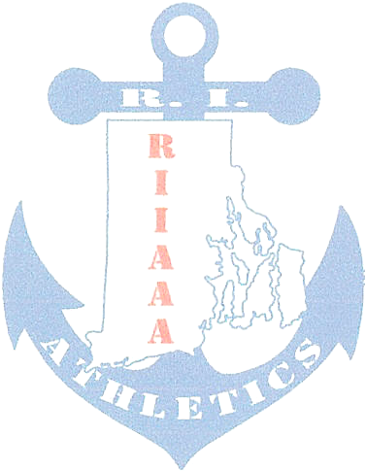
The RIIAAA Executive Board would like to thank its members for all its dedication to athletics in the state of Rhode Island. Through your effort, student-athletes are able to attain higher goals and enrich their lives through sport.

We would also like to make you aware of our efforts to find better avenues to communicate with you. Our duty is to represent you and your needs to the best of our ability. Should you have an issue or idea that you feel our membership needs to be aware of please contact one of us? You are also encouraged to attend any Executive Board meeting to voice a concern or just see what we do once a month at the RIIL at RIC.

The following important information, which has come out of discussions from our recent meeting, is to help keep you aware of current issues or concerns in Rhode Island athletics.
- Kevin Ryan, Scituate, was welcomed to the RIIAAA Executive Board as a new board member. There is still one vacant seat on the board. If you have been a RI Interscholastic Athletic Administrator for at least three (3) years and are interested to be considered for this vacancy, contact Elaine Botelho at doubleeb48@cox.net..

- Athletic Directors serving as either Director or Co-Director of a sport committee are reminded to send meeting report(s) to Bob Palazzo Robert.Palazzo@ppsd.org as soon as possible. In order for Jeff Maidment and Mike Traficante to best serve you at Principals’ Committee on Athletics meetings, Bob would need to pass on sport committee resolutions in advance of the PCOA meetings.
  - Winter sport interpretation meetings are scheduled through October 2013. Go to www.riil.org to see a listing of sports meetings.
  - Girls’ Soccer playoff meeting is scheduled for October 24, 2013.
  - By-Laws Committee meeting is October 23, 2013 at LaSalle Academy, Providence.

- RIIAAA membership renewal forms for 2013-2014 are now due.

- Sport Committee Reports:
  - Boys’ Basketball reported that the finals of playoffs are schedule for March 22, 2014.
  - Competition Cheer reported that ¼ points will be used this season rather than 1/10s. Alignment of teams will be done annually due to the declaration of co-ed programs following team tryouts. The state championships will be held at the Providence Career Technical Academy the weekend of March 15, 2014.
  - Girls’ Soccer reported that the coaches’ association has scheduled JV playoffs as a one day event.
  - Golf will be presenting a requested for the sport committee to complete a study on moving the season from spring to fall for 2016-2018.
  - Hockey reported the schedule will be public during the week of October 21^{st.}
  - Sports’ Medicine reported on Heat Acclimatization and coach compliance.
  - By-Laws committee has added Frank Geiselman, Cumberland and Chuck Jones, Coventry as non-board members to its committee.
  - Co-Op committee reported making use of resources from neighboring states to create a baseline for defining RIIL Co-Op teams. They will continue to meet to refine these regulations.

- Principals’ Committee on Athletics: No report, next meeting is November 2013.

- The RIIAAA (www.RIIAAA.org) and The RI Injury Fund (www.RIInjuryFund.org) Websites are getting a make-over. Expect to see changes shortly.

- The NIAAA Section I Summer Institute is scheduled for June 30-July 2, 2014. The committee is looking for at least 60 attendees to fill the block of rooms contracted by Section 1.

- RIIAAA Award nomination forms go out the first week of November 2013. Nominations will also be considered at the Appreciation Breakfast the first week of December 2013.

- Kudos to Ken Nally and Bill Miner for hosting the RIIAAA October board meeting. It is always a pleasure to meet at the Championship Award Guys, Plainville, MA.

Any questions or concerns, please contact Beth Penkala at: bethpenkala5@gmail.com

