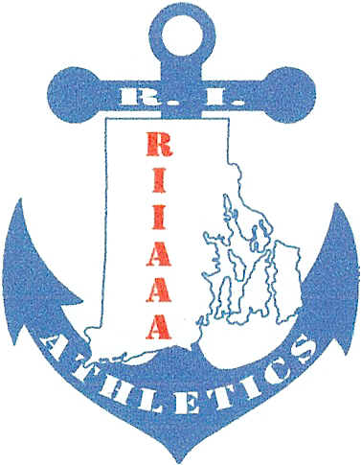
Rhode Island Interscholastic
Athletic Administrators Association
__________________________________________________________________________________________________________________________________________________________________________________________________________________________________________________________________________________________________________________________________________________________________________________________________________________________________________________________________________________________________________________________________________________________________________________________________________________________________________________________________________________________________________________________________________________________________________________________________________________________________________________________________________________________________________________________________________________________________________________________________________________
RIIAAA
Appreciation Breakfast

Thursday, December 1, 2016
9AM-11AM
Airport Radisson

As a retiree RIIAAA member is good faith, there is no cost to you unless you invite a non-member guest. If you plan on bringing a guest you would fill out this form and return with add-on payment per person. Otherwise, simply email me with your response as to whether or not you will attend.

$20 per person payable to RIIAAA along with number of attendees due no later than 11/23/2016 to

Beth Penkala, CAA
51 Almy Avenue
Warren, RI 02885
Bethpenkala5@gmail.com
PAYMENTS WILL NOT BE ACCEPTED AT THE DOOR
-----------------------------------------------------------------------------------------------------------------------------------------------------------------

Name:_______________________ School:__________________

________ No. of Attendees


